**Building a Face-Detection App on AWS Cloud**

**1.AWS login screen with username**

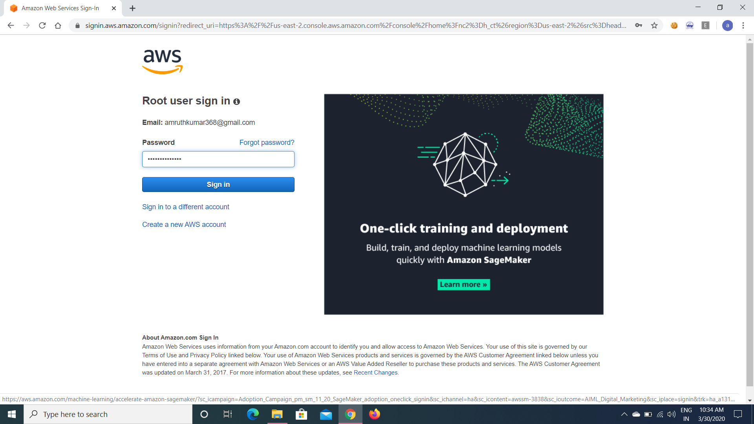

**2.EC2-dashboard :-**

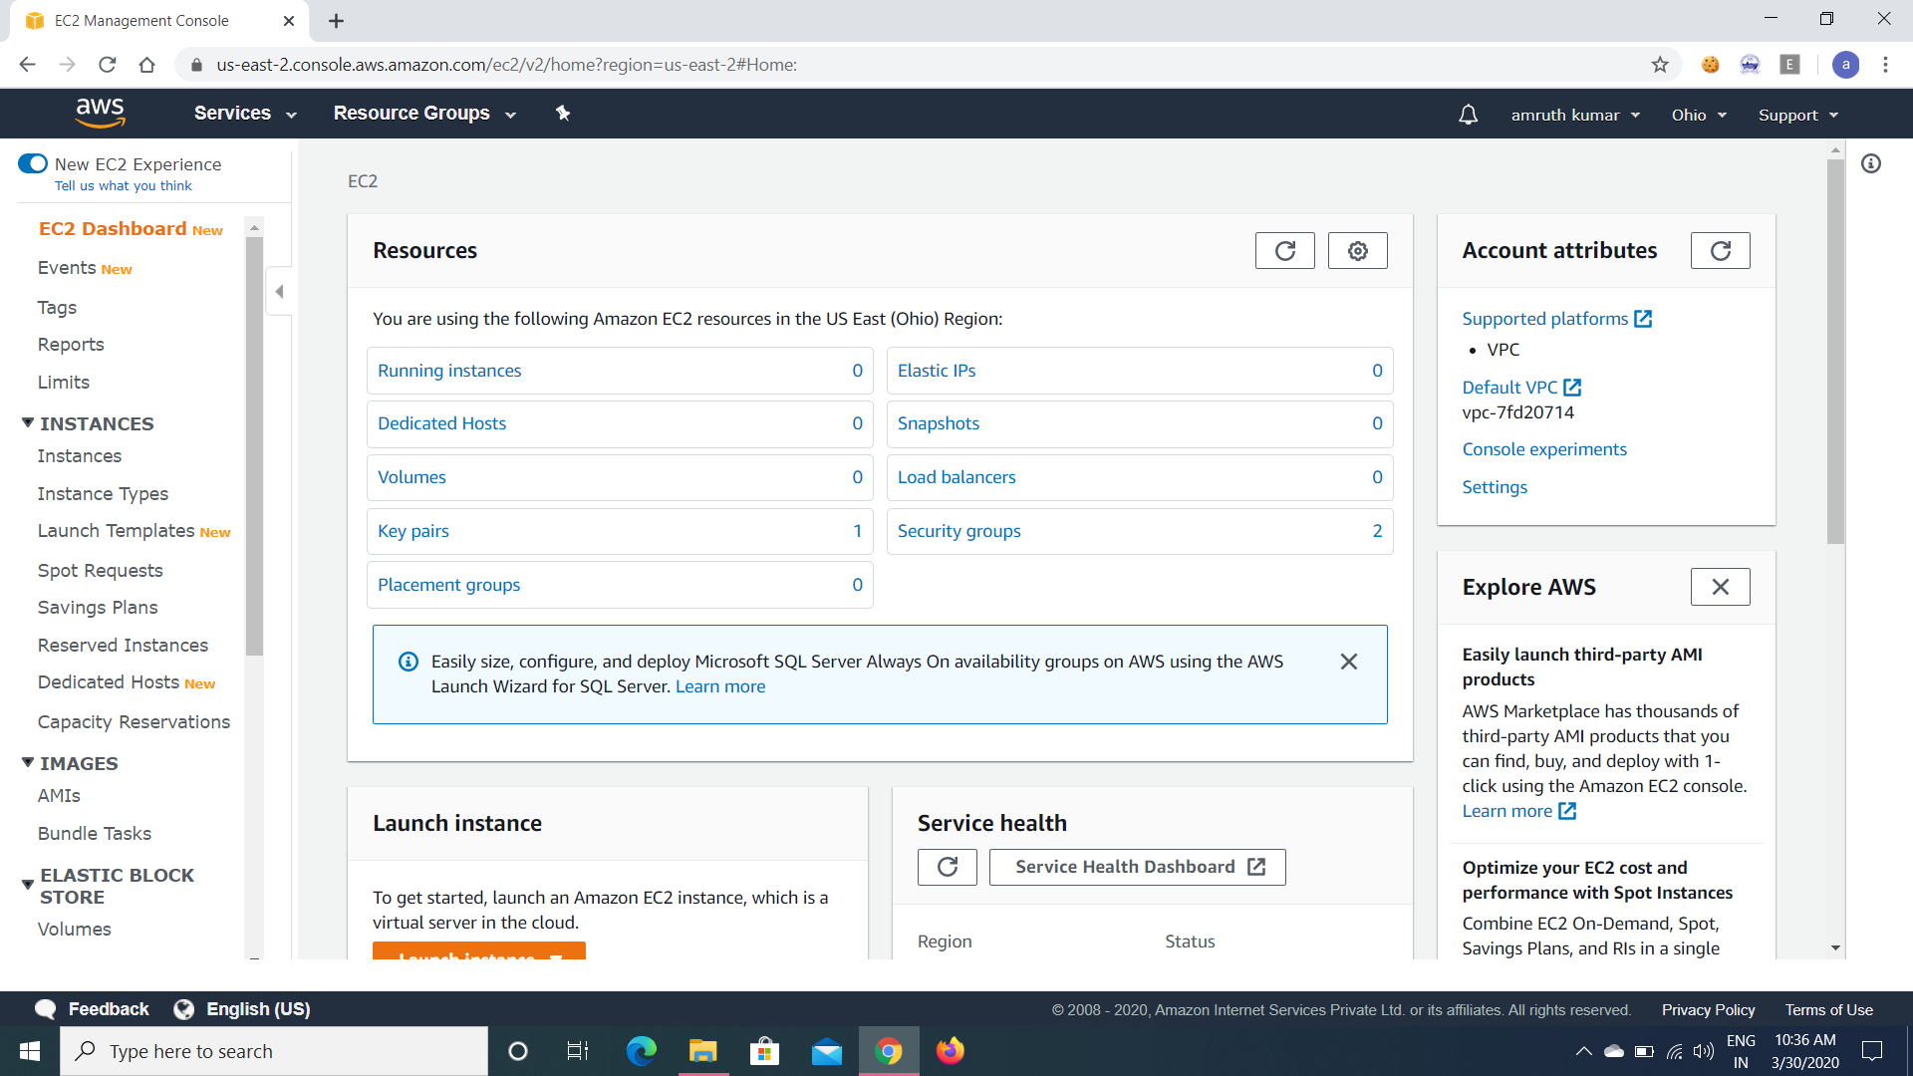

**3.S3 Dashboard :-**

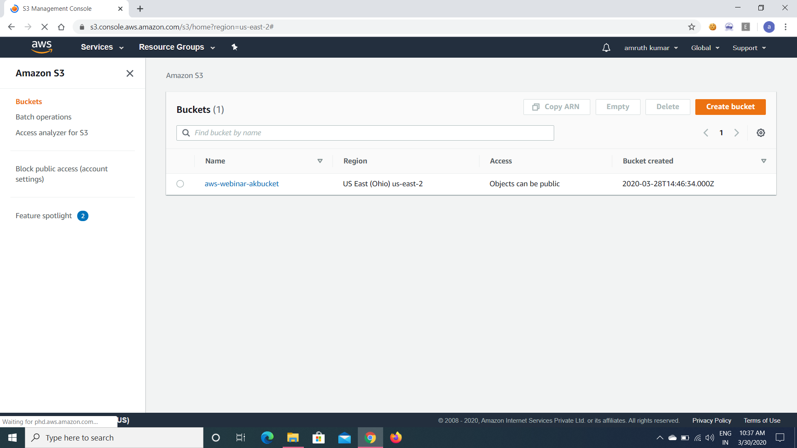

**4.Rekognition Dashboard :-**

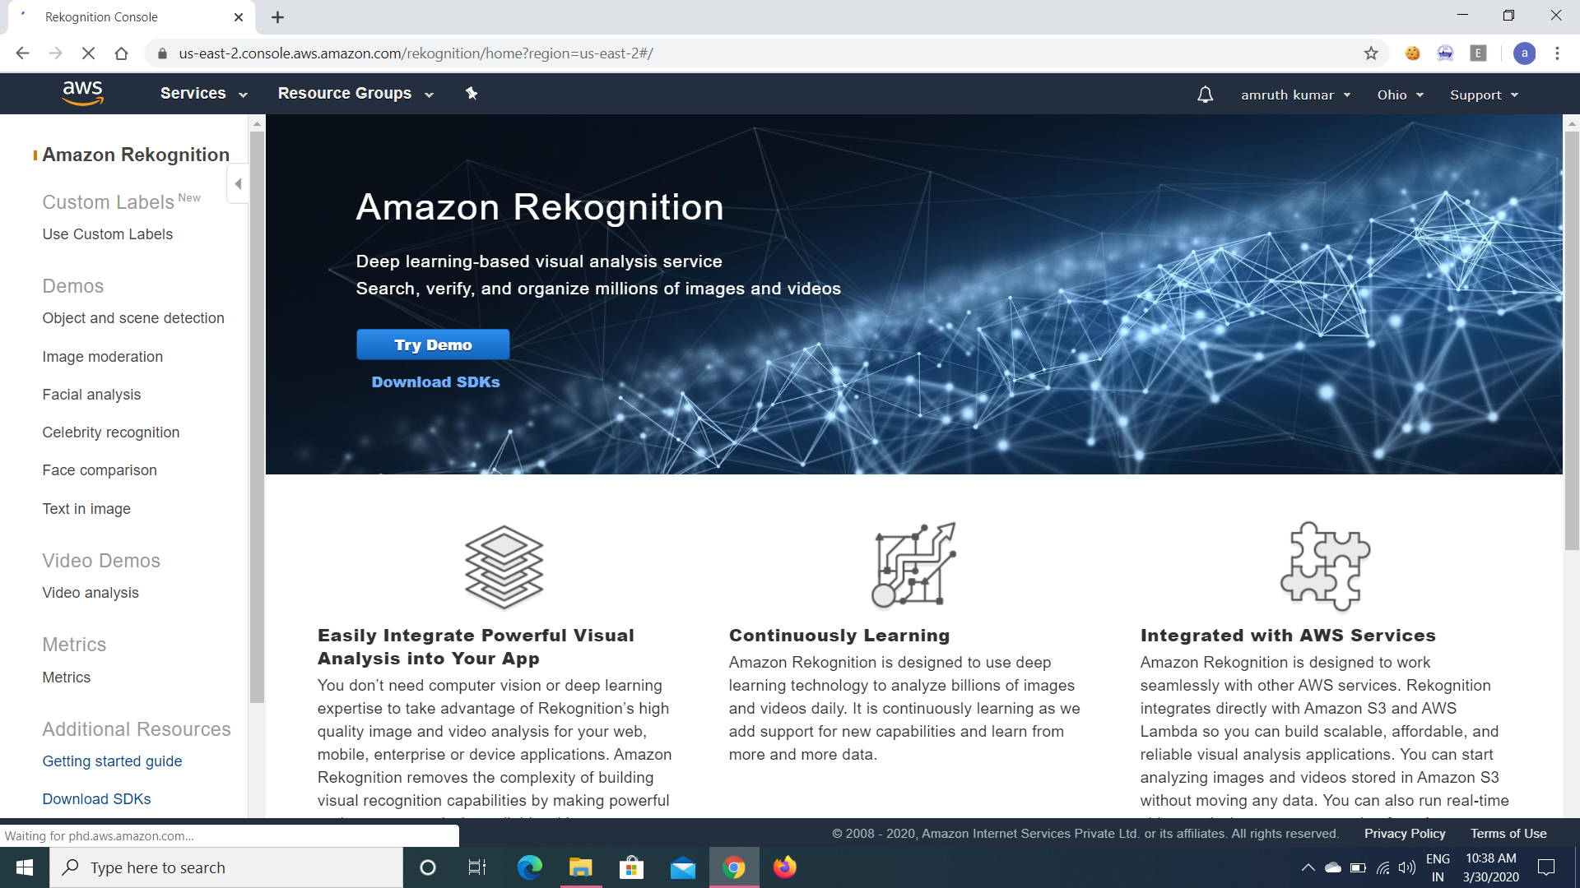

**EC2 :-**

5.Choosing an AMI :-

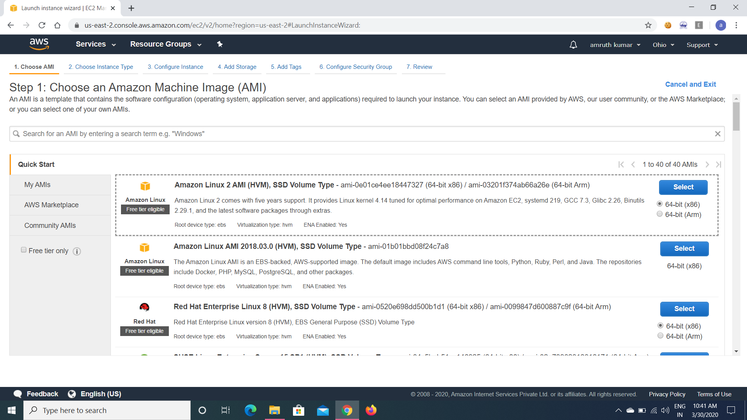

6.Choosing Instance type:-

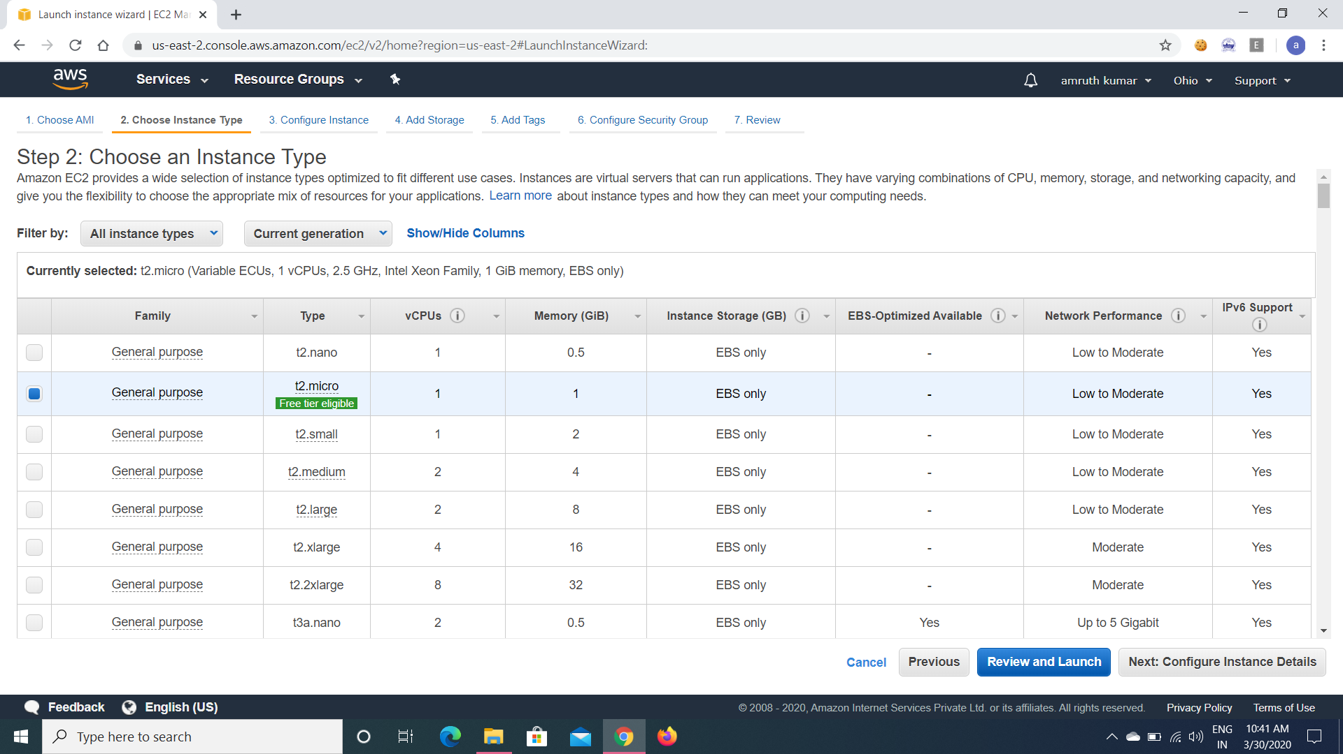

7.Adding storage :-

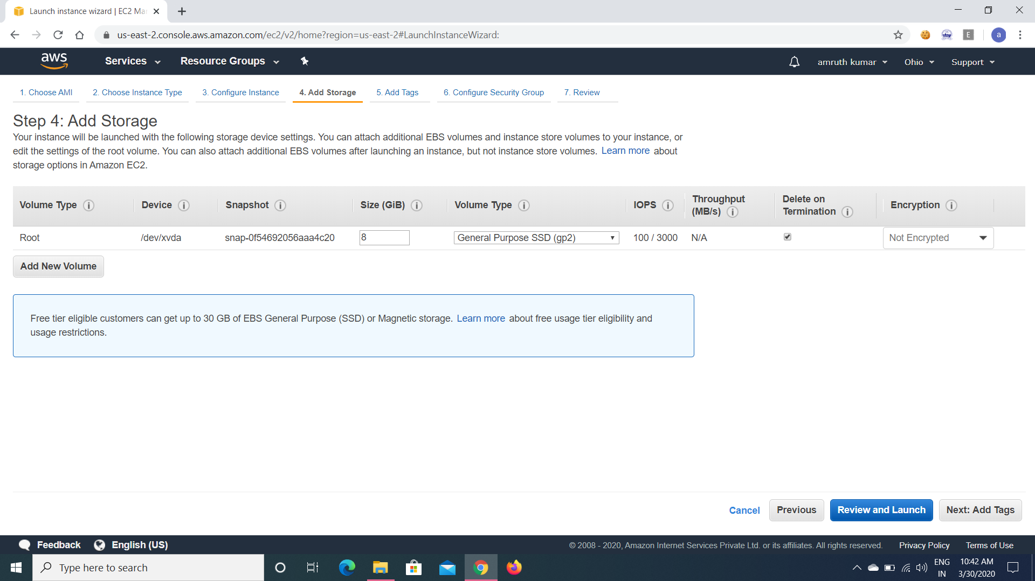

8.Configuration Security Group :-

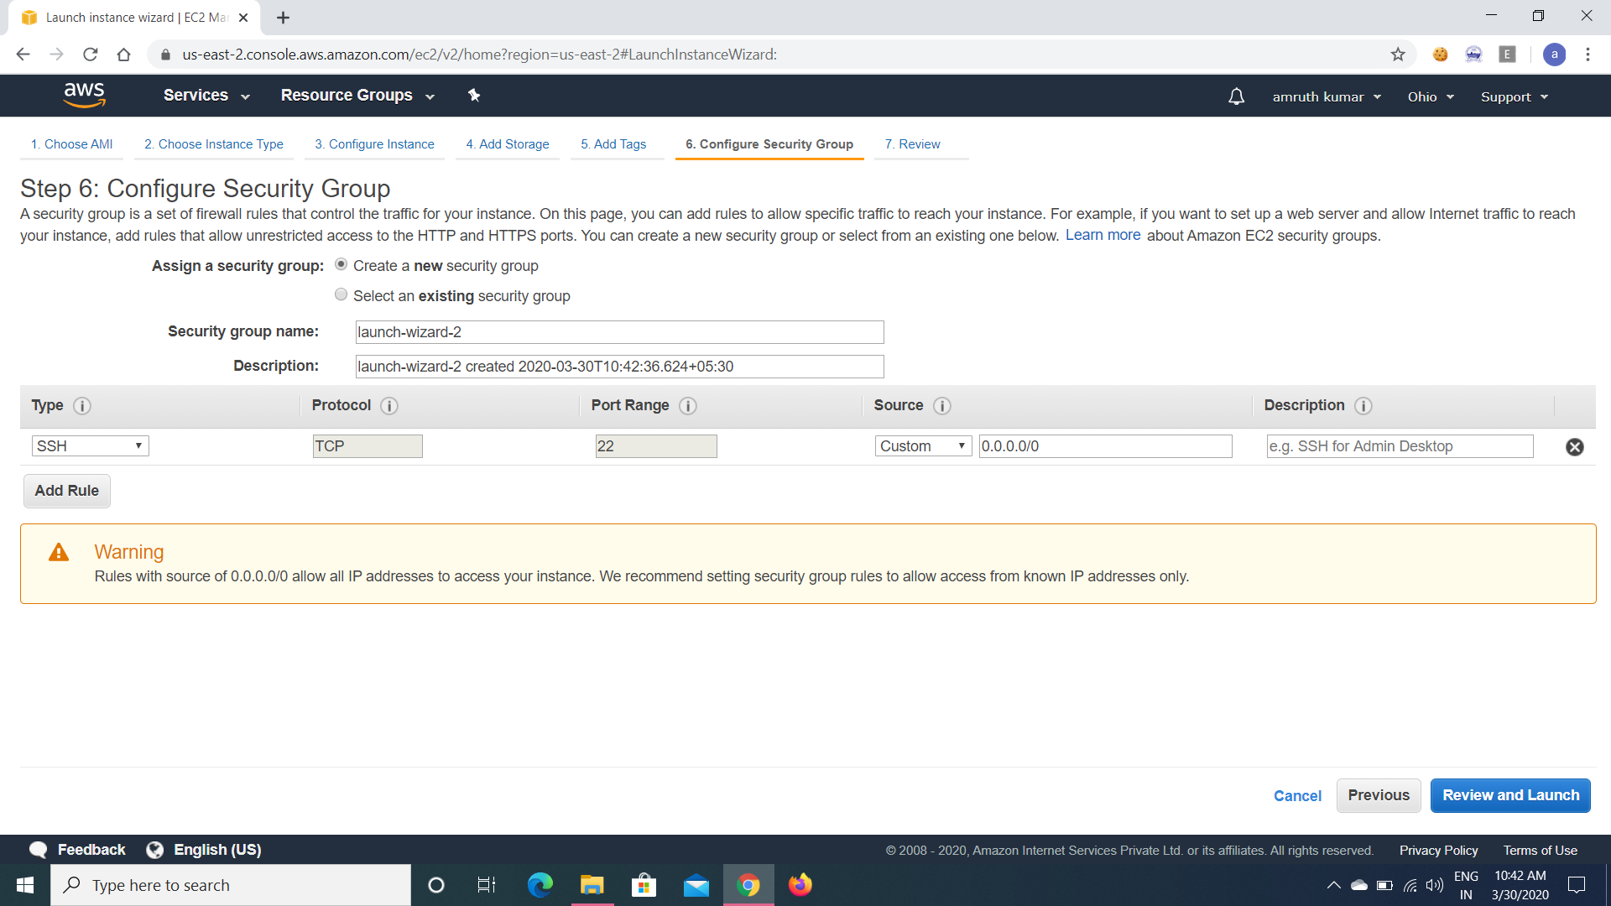

9.KeyPair download :-

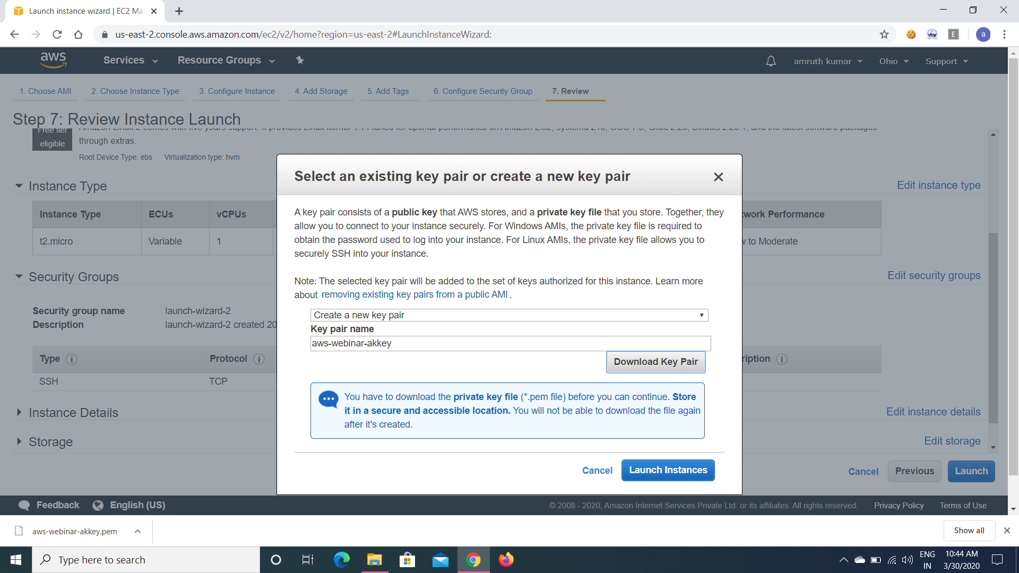

10.Puttygen conversion from pem to ppk:-

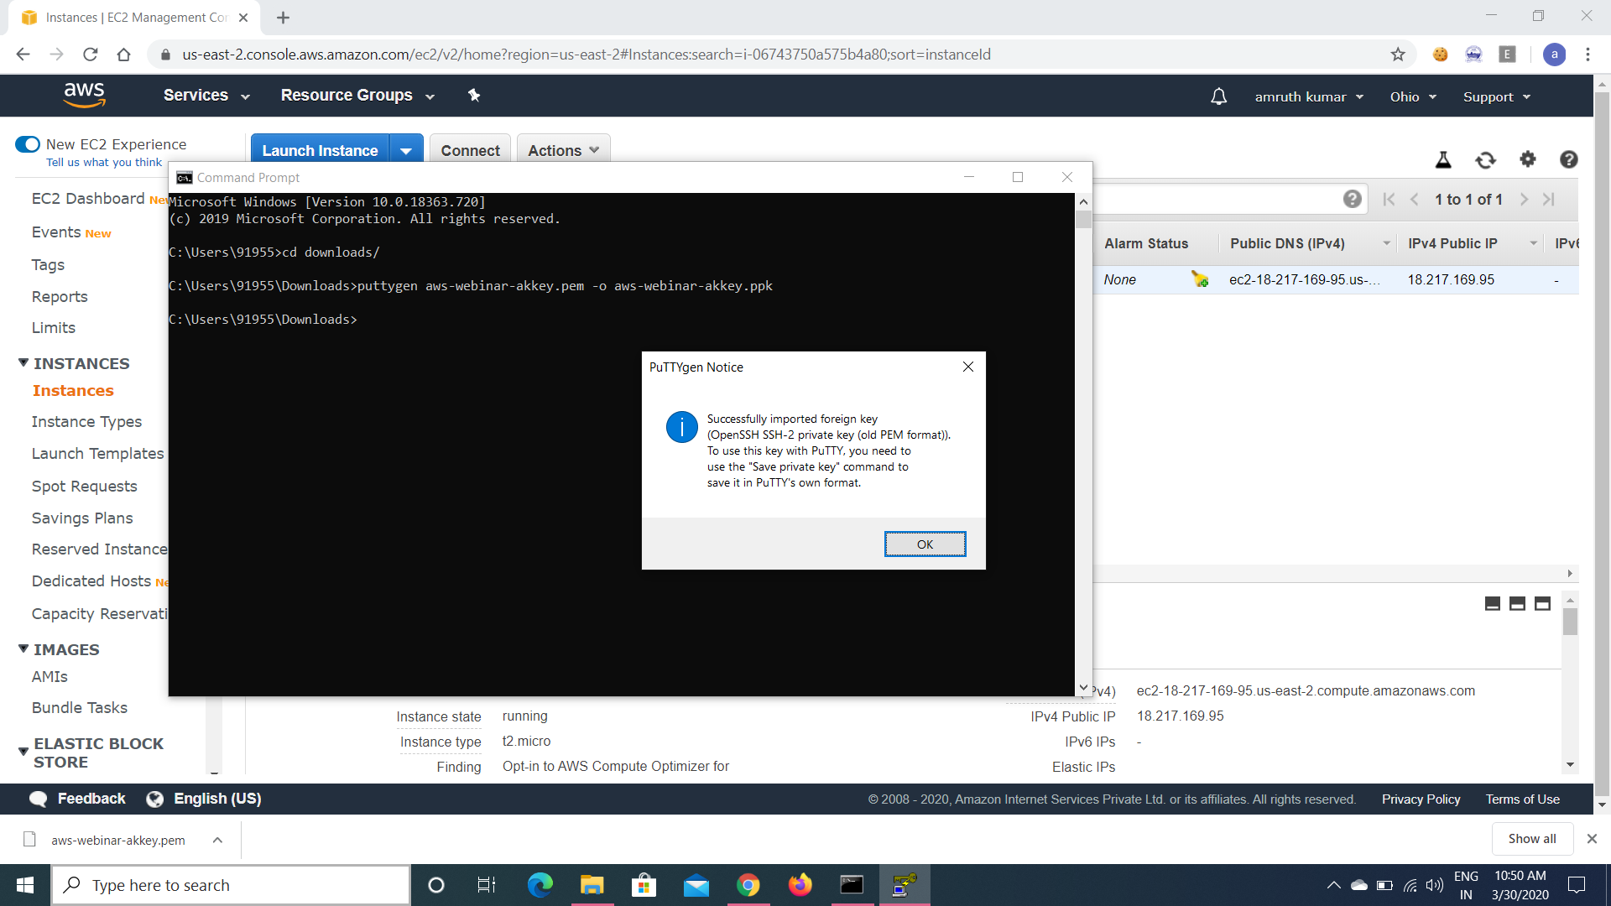

11.Logged in EC2 black-screen

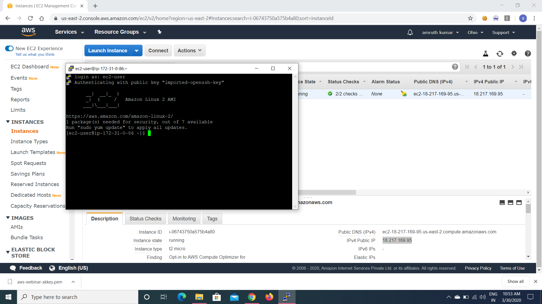

**S3:-**

12.Creating a bucket :-

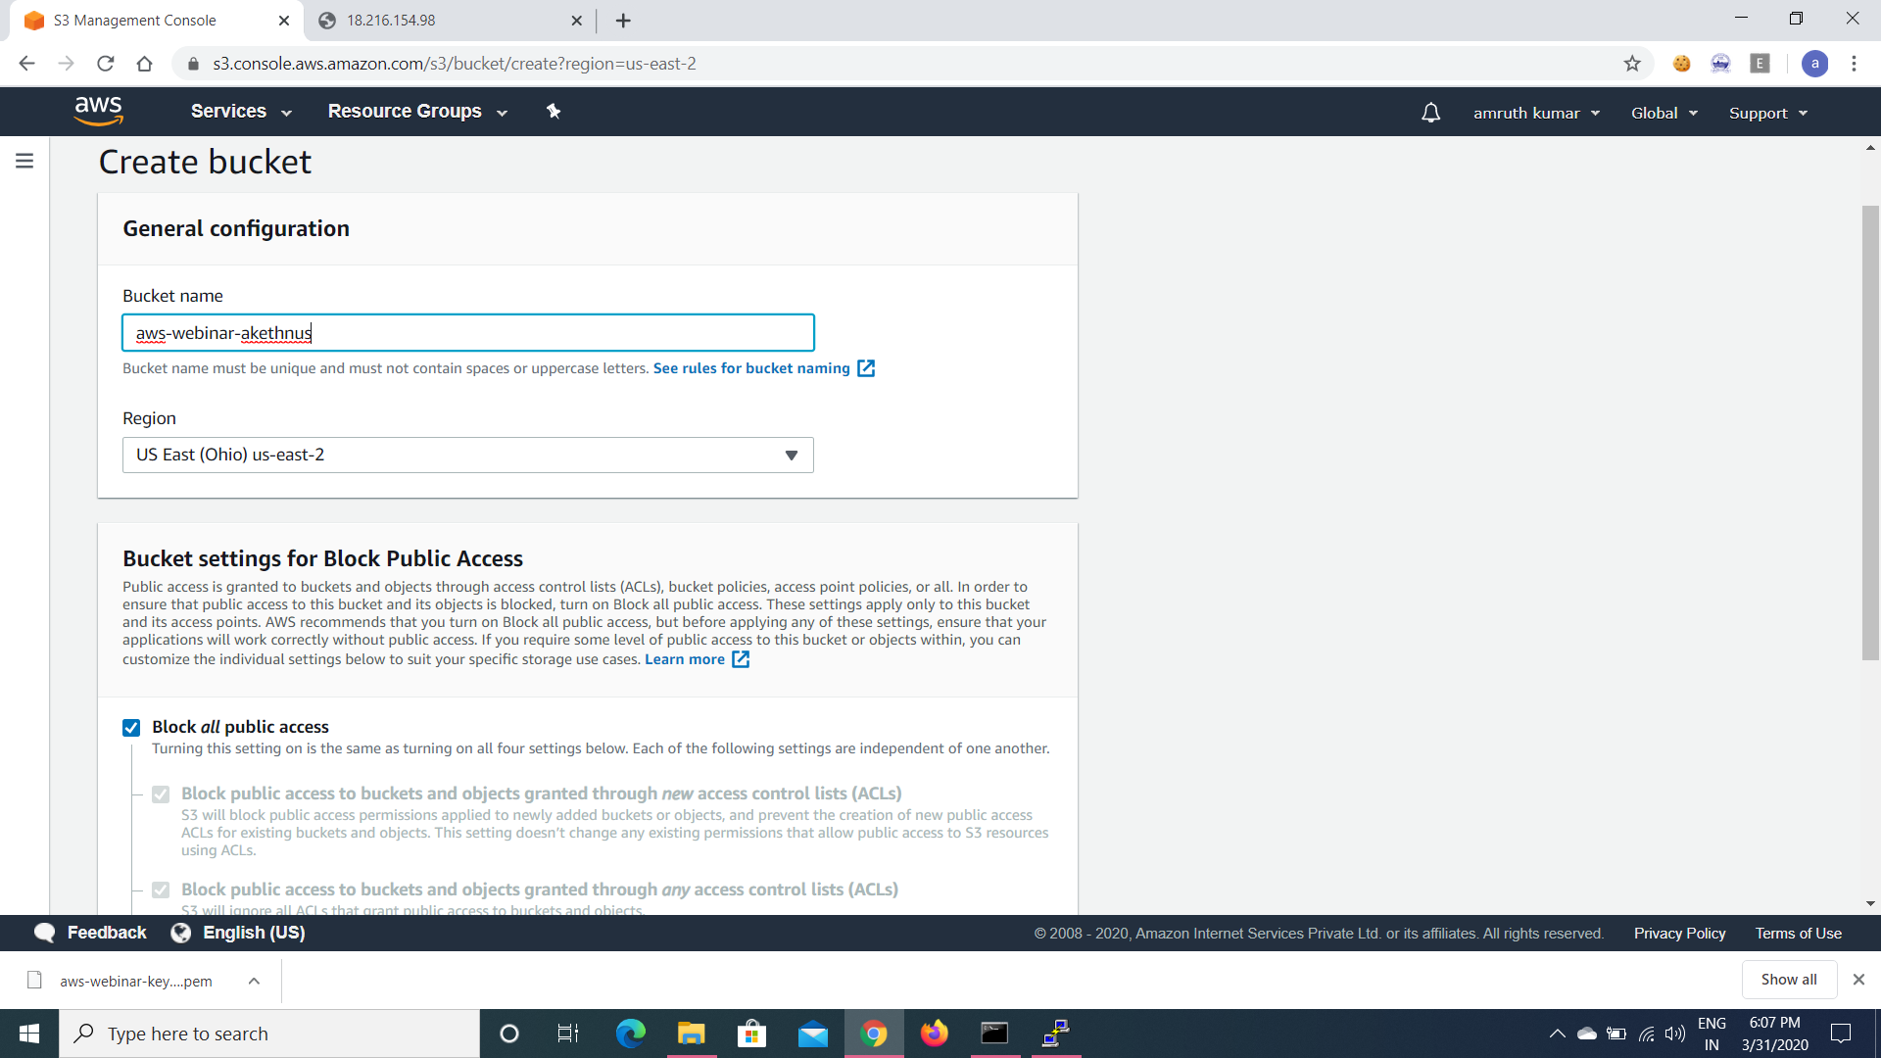

13.Uploading an object :-

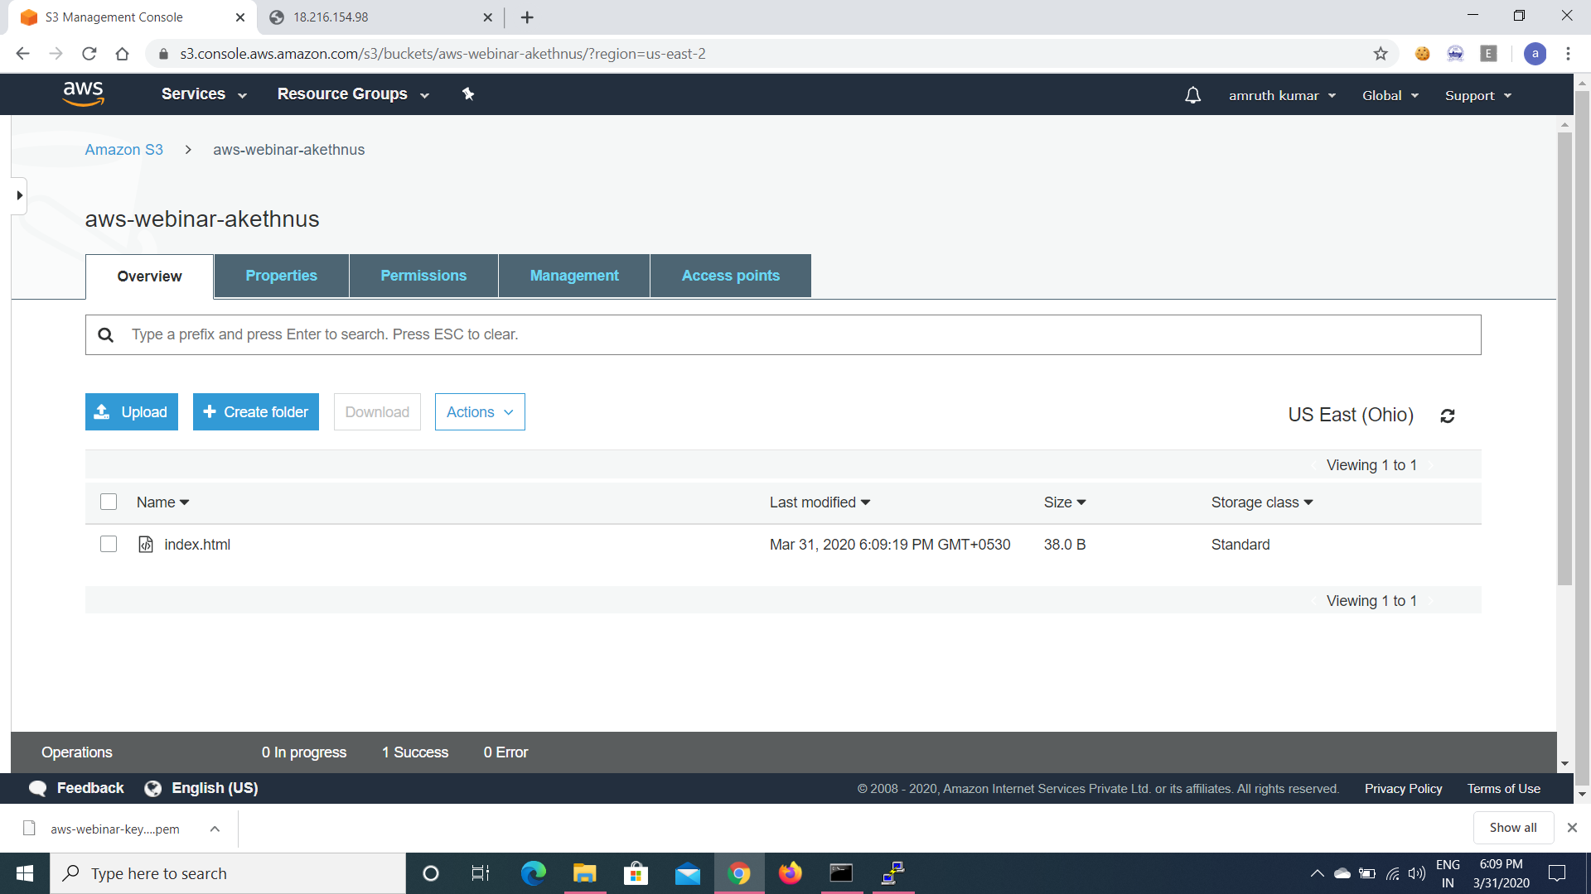

14.Enabling static website:-

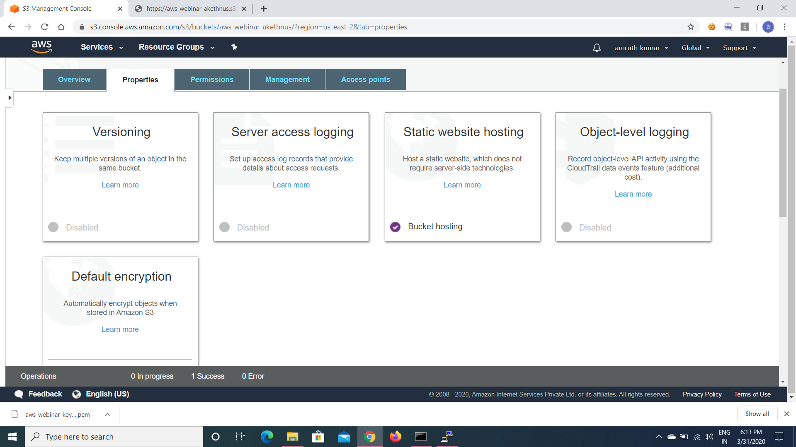

15.Making the object public :-

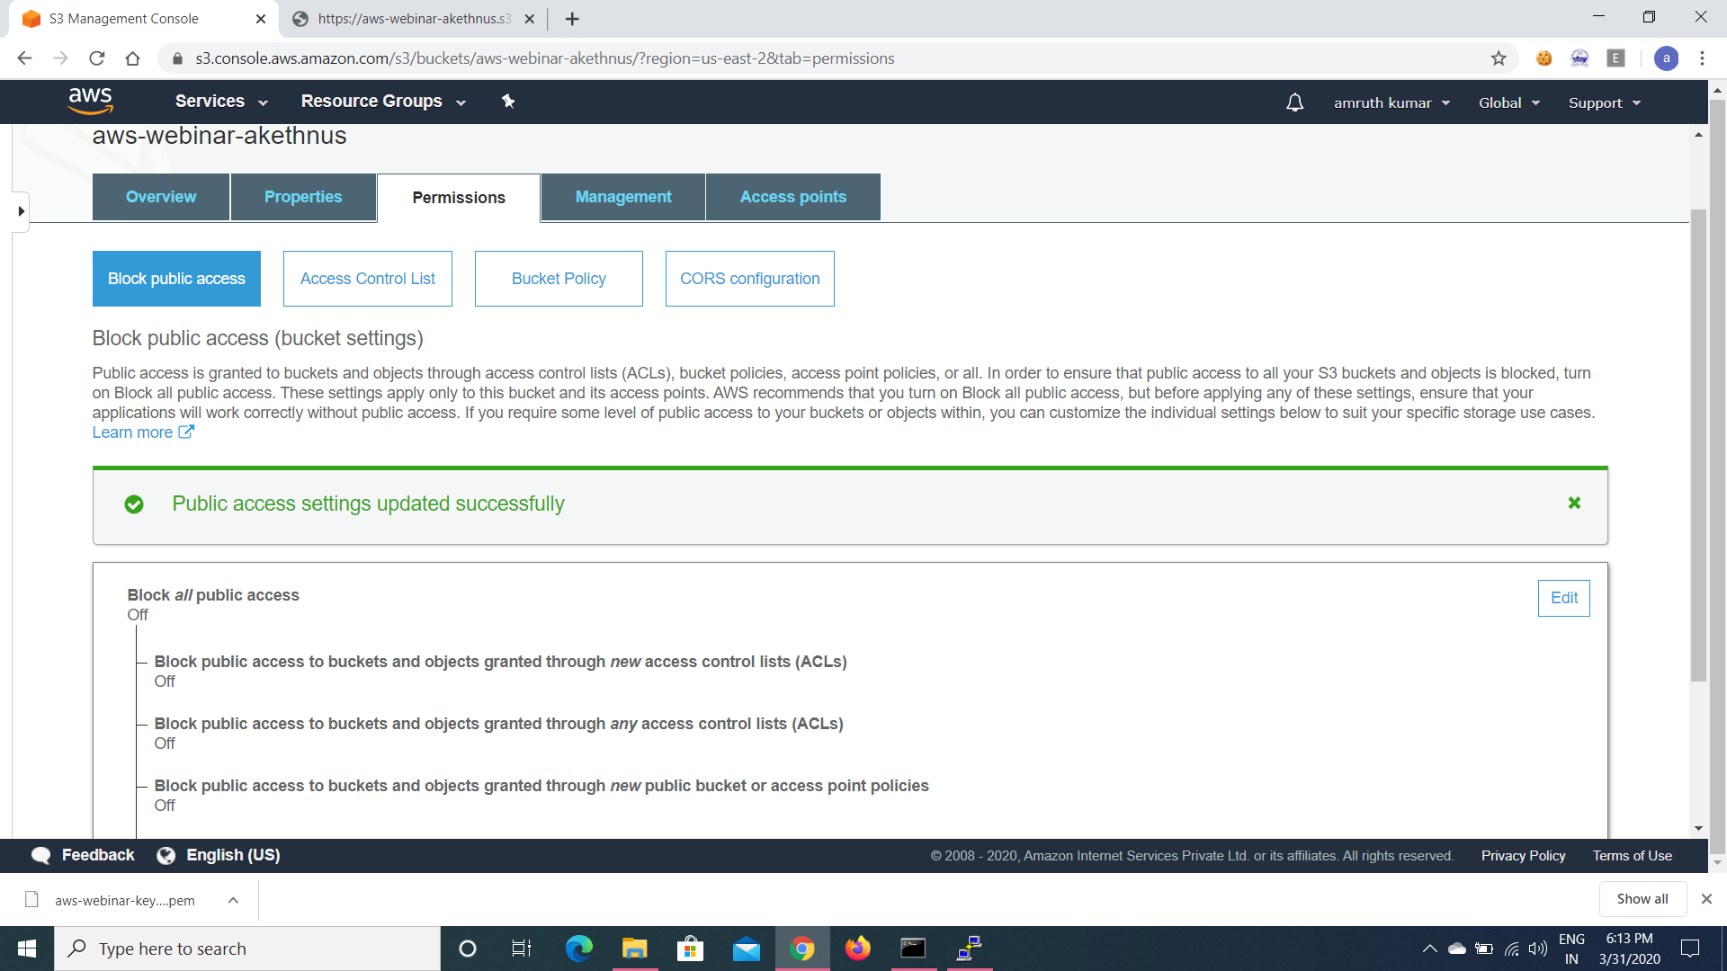

16.Checking the S3 link on the browser :-

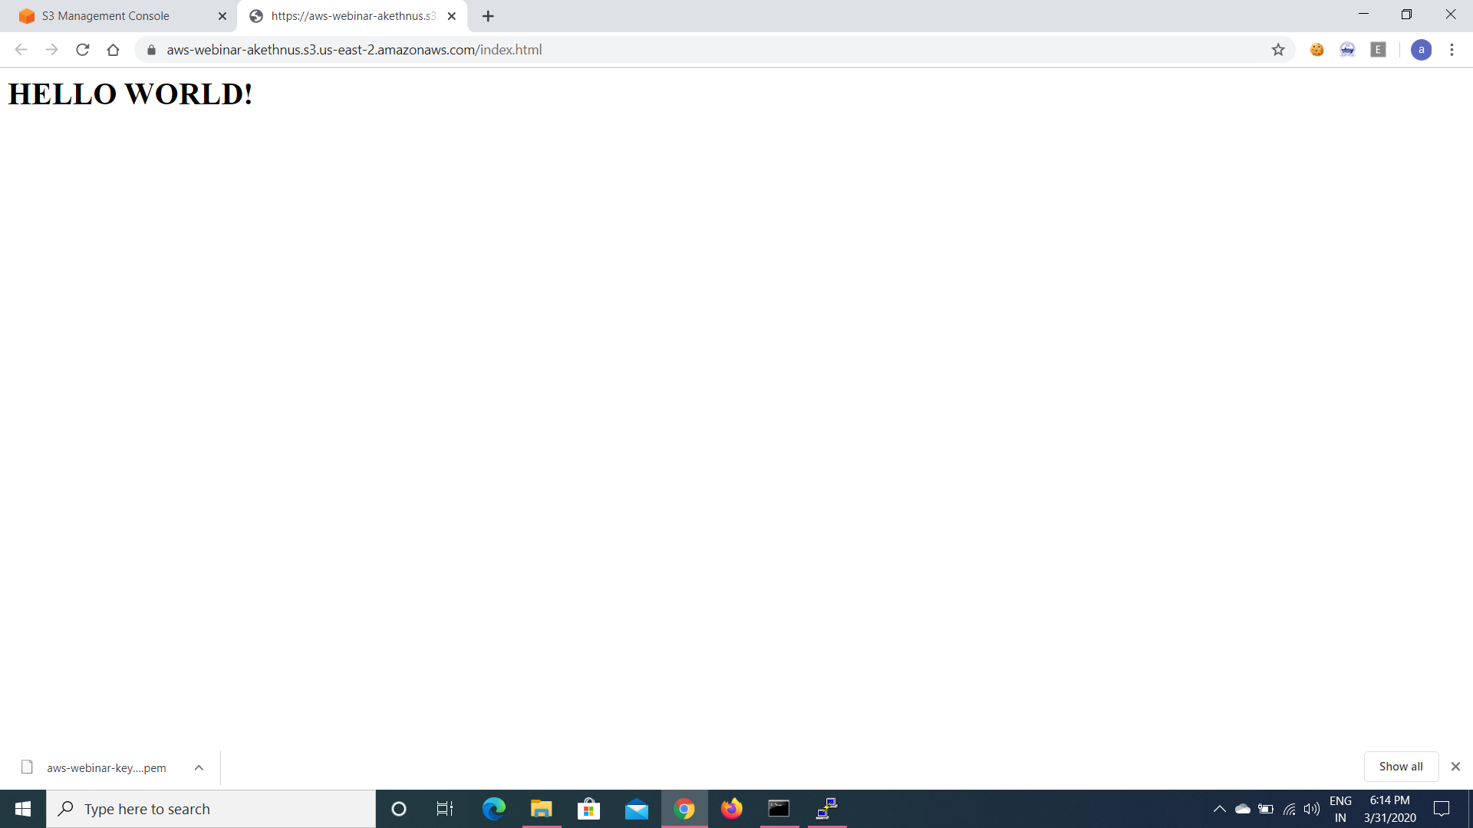

**REKOGNITION:-**

17.Face Recognition :-

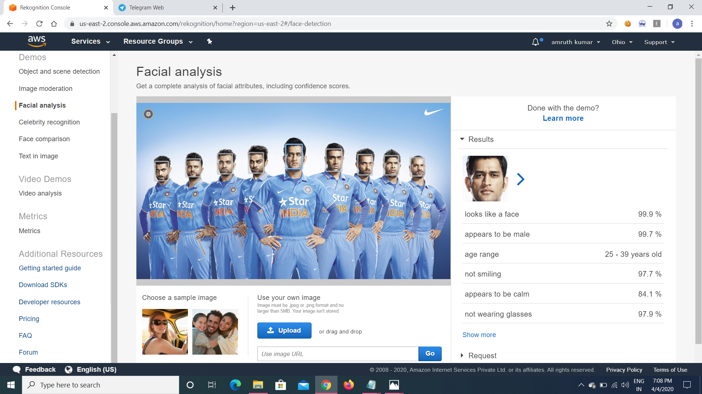

18.Face compare :-

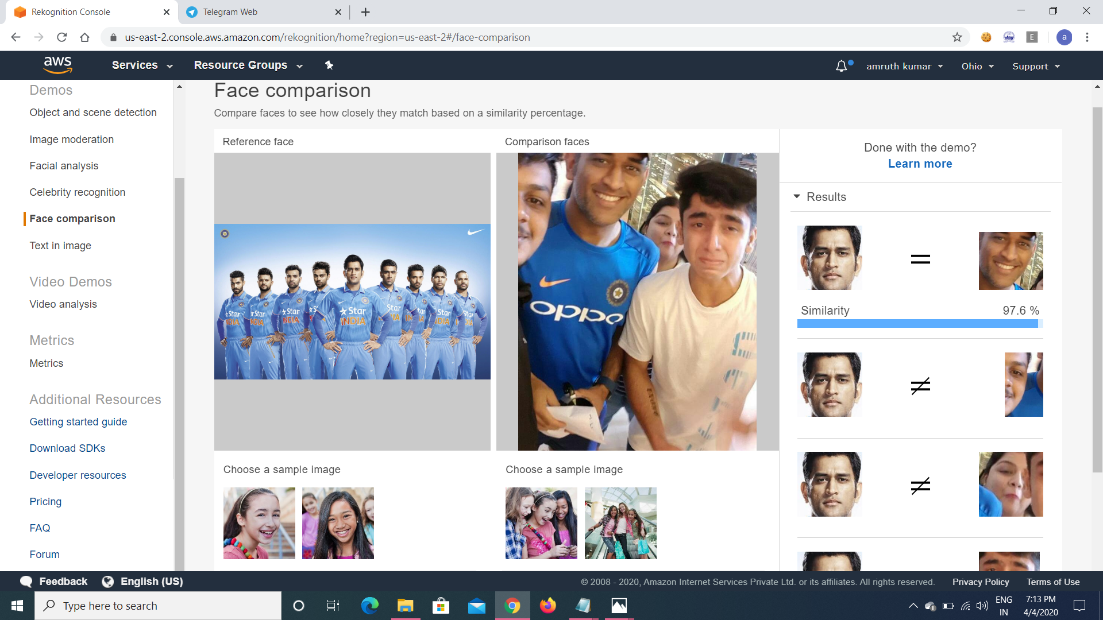

19.Celebrity Recognition:-

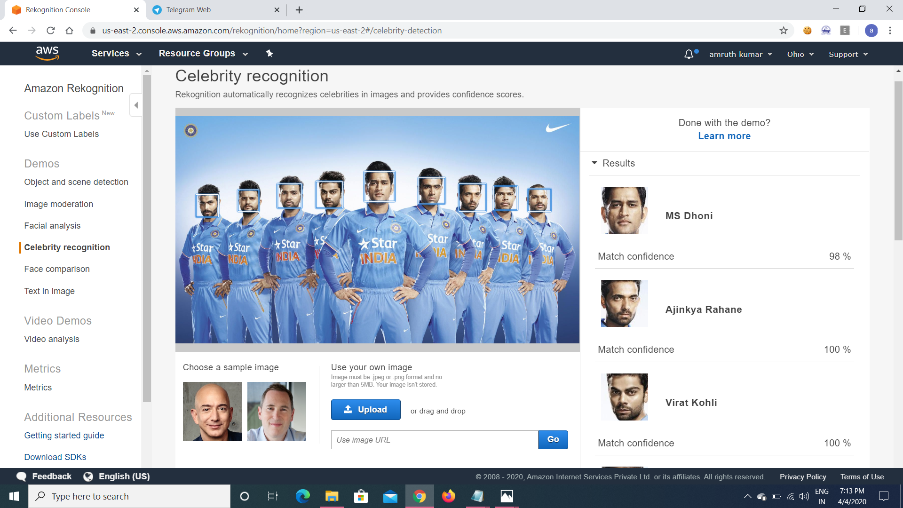

20.Text in Image :-

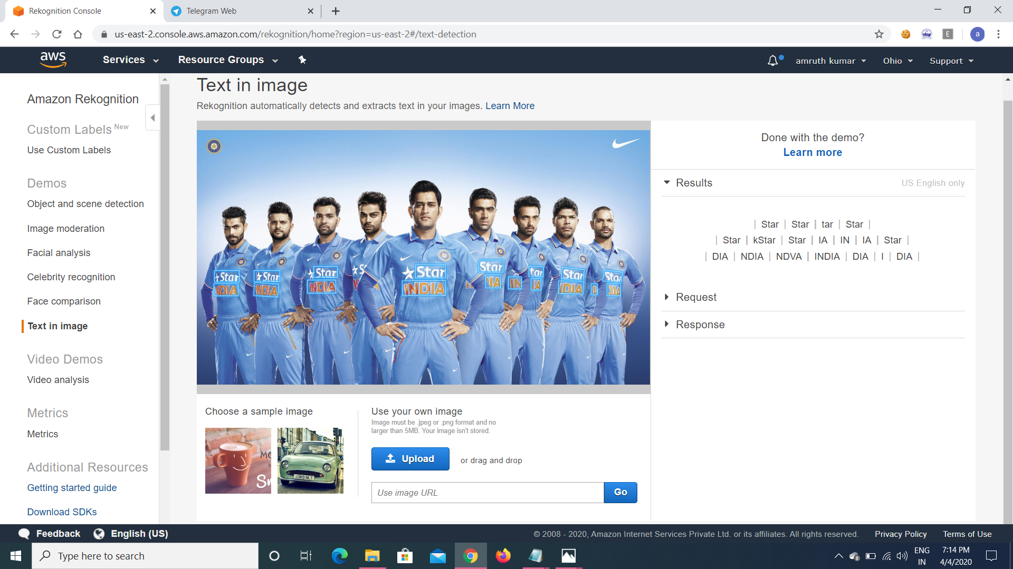

**EC2&S3** :-

21.Installing AWS-sdk :-

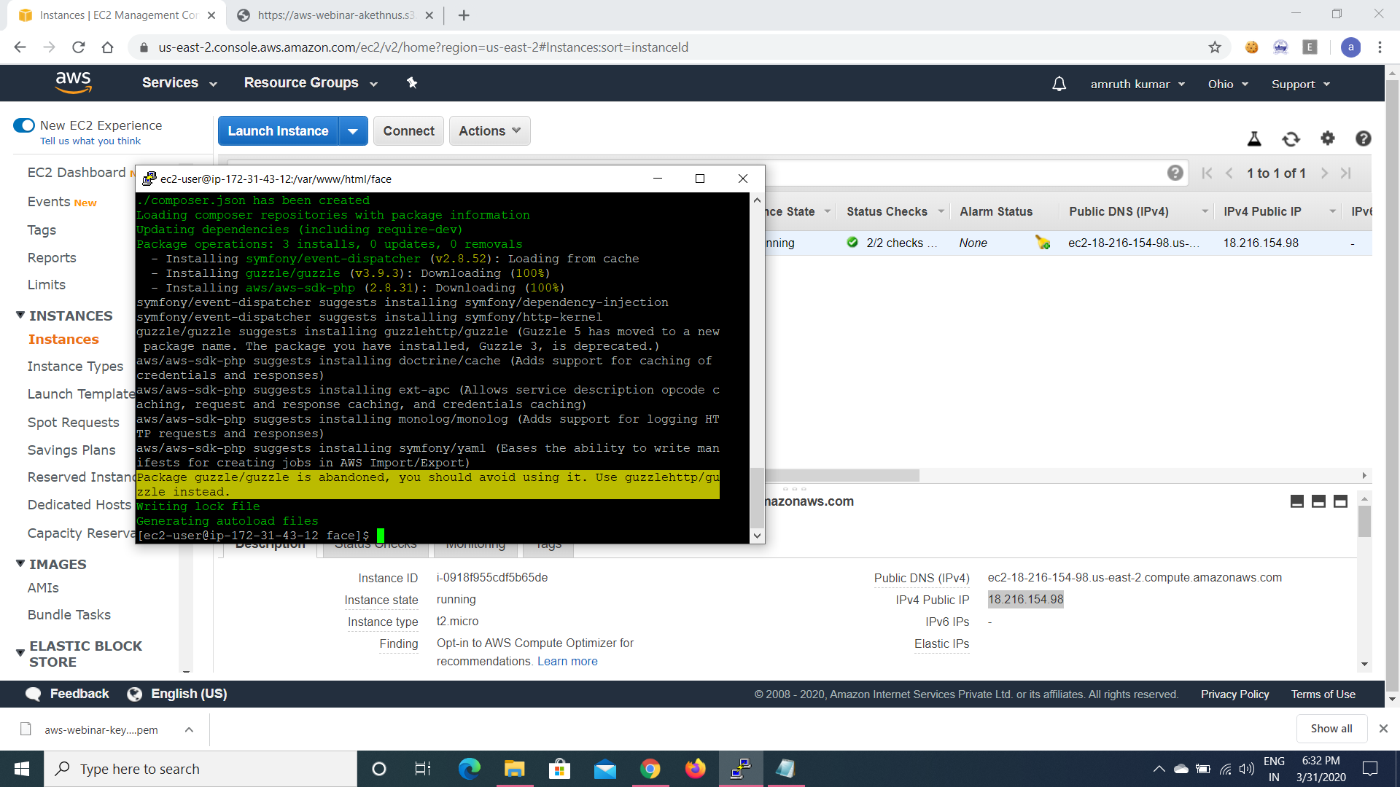

22.Installing php:-

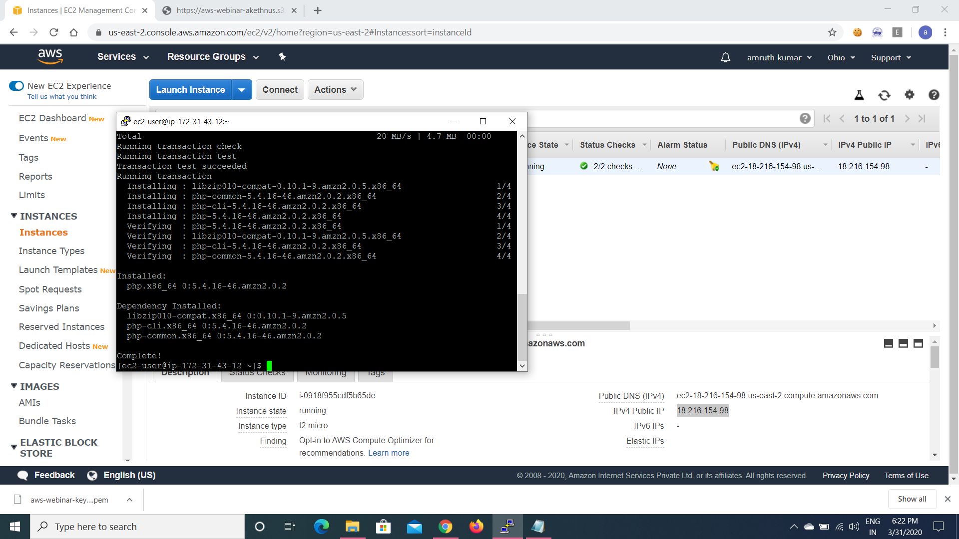

23.index.php file code :-

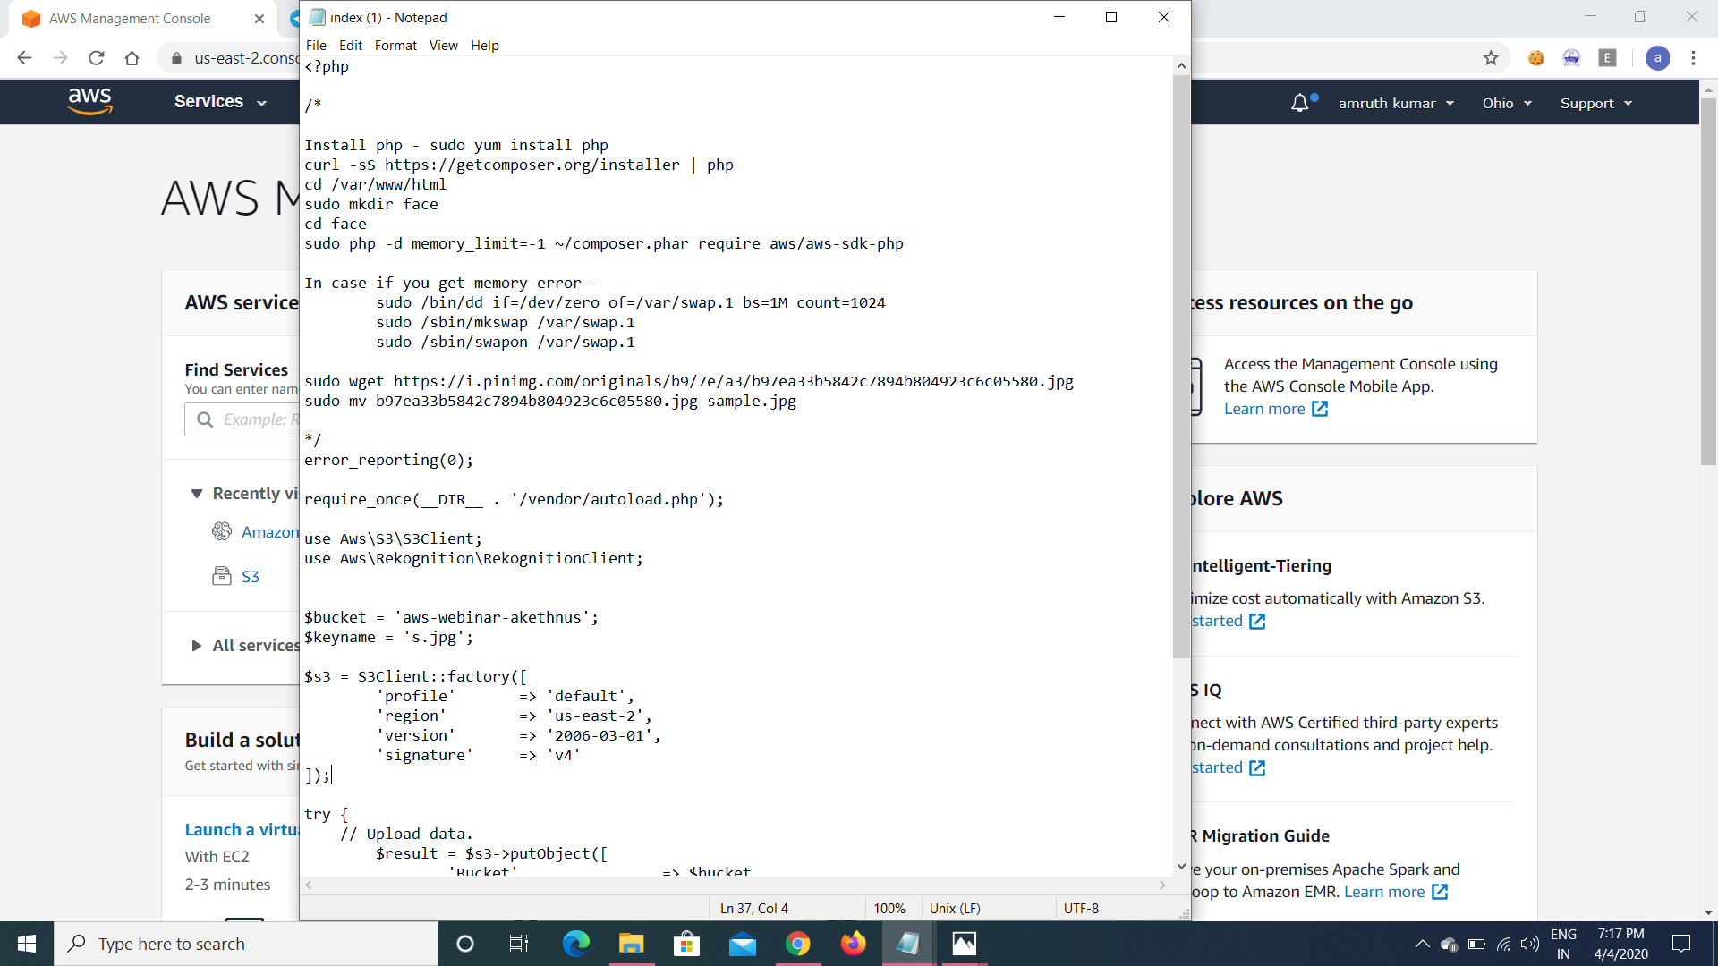

24.Upload success :-

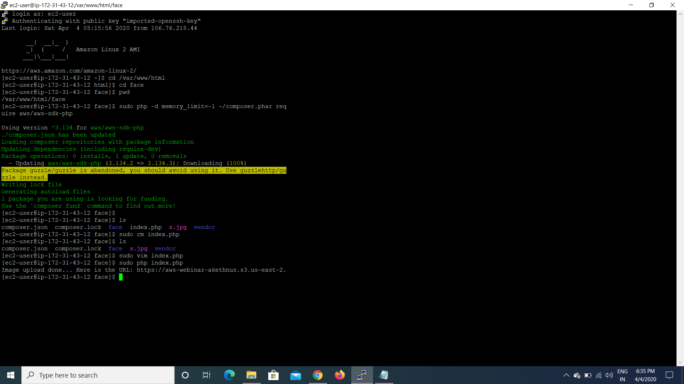

25.Face detect success screenshot :-

